j0232899

**The Leopold PS House Cross Country is quickly approaching!**

When: Tuesday 18th March

Time: 9.00am-11am

Students

Involved: Whole school

Race Distance:

Grade Prep Fun Run = 350m

Grades 1 & 2 Fun Run = 650m

9/10 yrs = 1.2km

11 yrs & 12/13yrs = 2.3km

Order of Events:

9:15am Grade Prep Boys

Grade Prep Girls

8/9/10yr Boys ***(Presentation of Preps)***

8/9/10yr Girls

Grades 1 Boys ***(Presentation of 8/9/10 years)***

Grades 1 Girls

11yr Boys ***(Presentation of Grade 1’s)***

11yr Girls

Grades 2 Boys ***(Presentation of 11 years)***

Grades 2 Girls

12/13yr Boys ***(Presentation of Grade 2s)***

12/13yr Girls

***(Presentation of 12/13 years)***

Selection for School Cross Country Team:

The top 10 students, per age group will be selected.

**Ages are calculated by the age the child turns at the end of the year;**

**8/9/10yrs, 11yrs, 12/13yrs as of 31st December 2014**

Presentations: Throughout the event

(Top 3 Placegetters in each race)

**Student Identification Numbers**

* These numbers have been emailed out to teachers. Please scroll down this document until you find your grade. If you do not find your student please email their name and I can allocate a number for them. (NOT RACE MORNING THOUGH)

**House Cross Country & Junior Fun Run**

**Tuesday 18th March(9-11am)**

1. All Prep-6 students are to participate. Only medical notes prevent this.
2. Teachers bring their class out onto the oval at 9:05am sharp ready to race Teachers head to their allocated marshalling points with their yard duty vests.
3. Prep, Grade 1 & 2 teachers have the option of taking their students back to their rooms after the fun runs, if they do not wish to watch the other races.
4. Students are encouraged to bring a drink bottle & wear their House coloured T-Shirt/socks (teachers can you check your students know what House they are in!) & appropriate running shoes; **Dennis**, **Lawson**, **Paterson** & **Gordon**
5. Grade Prep-6 Teachers: need to assist their students to write their numbers on their hand prior to the event.
6. **Ages are calculated by the age the child turns at the end of the year;**

**8/9/10yrs, 11yrs, 12/13yrs as of 31st December 2014**

1. Any students who cannot finish the course need to find the closest course marshal (yellow vests) and direct them back to the main oval.

***\*I have allocated the following marshalling positions for teachers. Please read the numbers then match it with the map or ask me if you have any questions.***

1. **Football Oval North End Goals SEDA**
   1. *Make sure children miss the goal posts*
   2. *Turn 10 year group around goals after 1st lap back towards finish line*
   3. *11 and 12 year group to continue through your check point for second lap. On second lap turn then around goals and back towards finish line*
2. **Fitness Track South Side SEDA**
   1. *Wave children through to tank*
3. **Fitness Track at Water Tank SEDA**
   1. *Turn children up towards Kensington Road*
4. **North Corner of School on Kensington Rd Pete R**
   1. *Turn children to run on footpath towards Bellarine Hwy*
5. **North Staff Car Park Entrance Danny**
   1. *Stop Cars from exiting and entering while runners are passing*
6. **South Staff Car Park Entrance Simone**
   1. *Stop Cars from exiting and entering while runners are passing*
7. **Corner of Hwy and Kensington Road Lynn M (McManus Corner)**
   1. *Perform a large U turn into school gate*
8. **Path in School boundary- SEDA**
   1. *Direct children down path to long jump pit*
9. **Football Oval South End Goals SEDA**
   1. *Wave children towards North End goals*
10. **Football Oval North End Goals – SEDA**
    1. *10 year- U turn children back to finish line*
    2. *11 year and 12 year- Wave them through for second lap then U turn them back to finish line*
11. **Finish Line SEDA and Ben Dew**
    1. *Line children up in order and take their tags*
    2. *Take Top 12 children in 10, 11, 12 year groups and the top 3 children in junior race over to tent*
    3. *Spike tags on wire face down*
    4. *Direct children back to viewing area after race*
12. **Administration Ilona/Gemma**
    1. *Type up Results as they appear- Name, Grade, Age group*
13. **Presentations- Eric Stribley and Adam**
    1. *Present medallions to first, second and third when next race has started*
14. **Crowd Control All teachers that have not been named.**
    1. *Ensure children are well behaved*
    2. *See something do something*

*17.* ***DJ Music****- Hayden*

1. **Lead Rider SEDA**
   1. The Rabbit- Hopefully no one catches him!

**TEACHERS WHO WILL RECEIVE APT**

* **Teachers that have APT will still get it but we do ask that you bring your children to the event at 9am.**

***The Course***

***Preps***

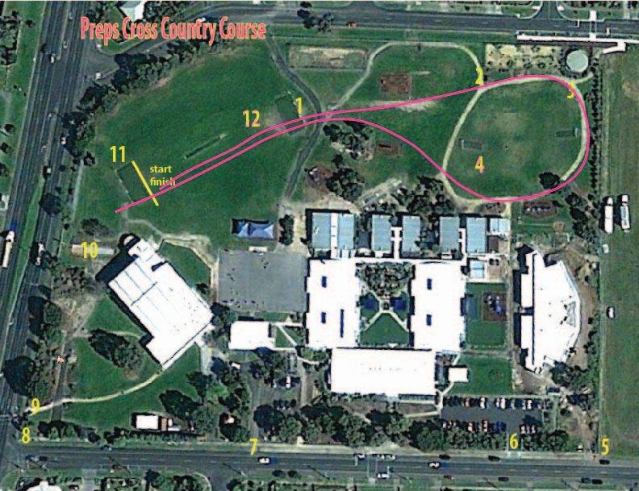

***Grade 1 and 2***

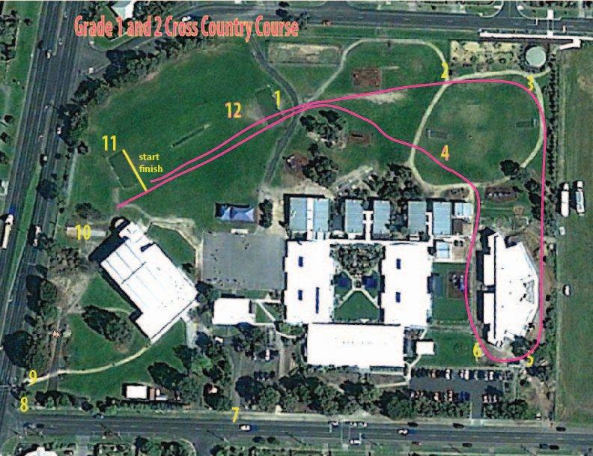

***Senior Cross Country***

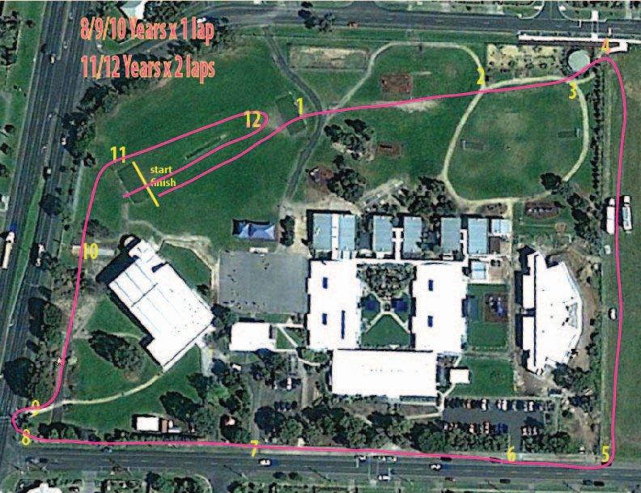

***Except they will remain inside the school boundary near fitness track.***