QR AMAZING RACE
- Use the map to navigate to each location.
- Scan the QR code with your IPAD to reveal a clue.
- Write the first letter of the answer under the corresponding location in the table below.
- Once you finish make your way back to the Kensington Building

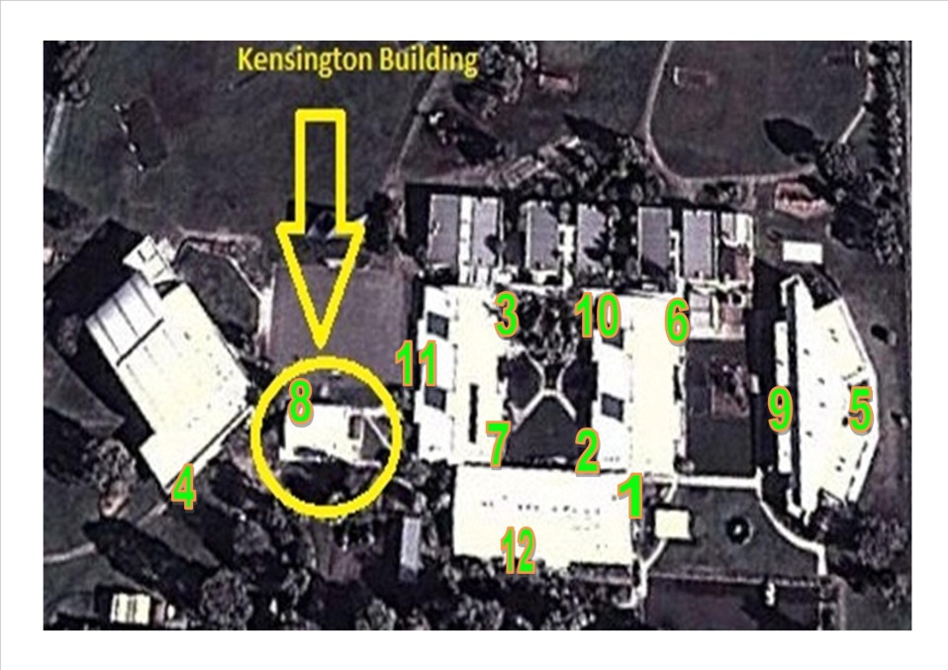

1 | 2 | 3 | 4 | 5 | 6 | 7 | 8 | 9 | 10 | 11 | 12

Unscramble the letters to reveal one of Australia’s most famous cities.

Answers
