To access the App on your phone, follow these simple steps:
1- Go to your App store (iTunes or Android Google Play)
2- Search and download the free ‘Team App’ application
3- Once in the Team App, sign up with an email address and you will be sent an email to confirm your registration

4- Once registered, within the Team App search for LEOPOLD PS PHYS ED & SPORT
Use the white cross in the top right hand corner to search
5- Select the LEOPOLD PS page, then you’ll have all this information right on your phone
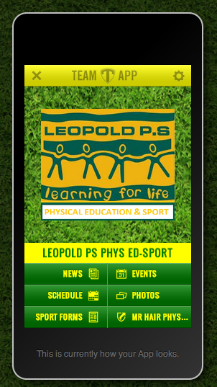
6- Parents and students can then request access to the ‘supporters’ membership.

Supporters of the club can access club news, events, schedules and results, photos and the web and social links too.
So this isn’t just for teachers and students, any member or follower of Leopold PS Phys Ed can use this App with ease on your phone.

Everyone is welcome, so download Leopold PS Phys Ed Team App now.

